IFT 360

Lab 2

# Concept 1

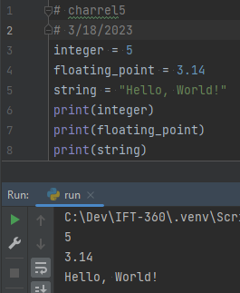

integer = 5

floating_point = 3.14

string = "Hello, World!"

print(integer)

print(floating_point)

print(string)

# 

# Concept 2

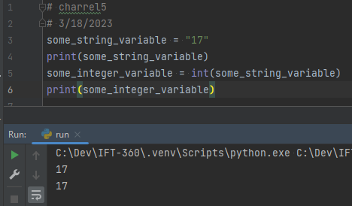

some_string_variable = "17"

print(some_string_variable)

some_integer_variable = int(some_string_variable)

print(some_integer_variable)

# 

# Concept 3

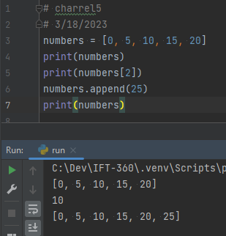

numbers = [0, 5, 10, 15, 20]

print(numbers)

print(numbers[2])

numbers.append(25)

print(numbers)

# Concept 4

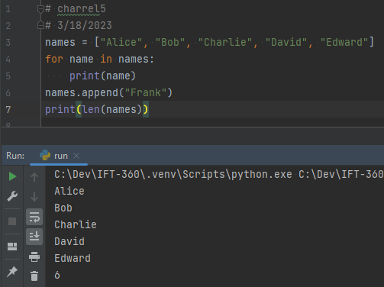

names = ["Alice", "Bob", "Charlie", "David", "Edward"]

for name in names:

print(name)

names.append("Frank")

print(len(names))

# Concept 5

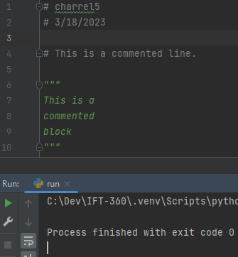

# This is a commented line.

"""

This is a

commented

block

"""

# Concept 6

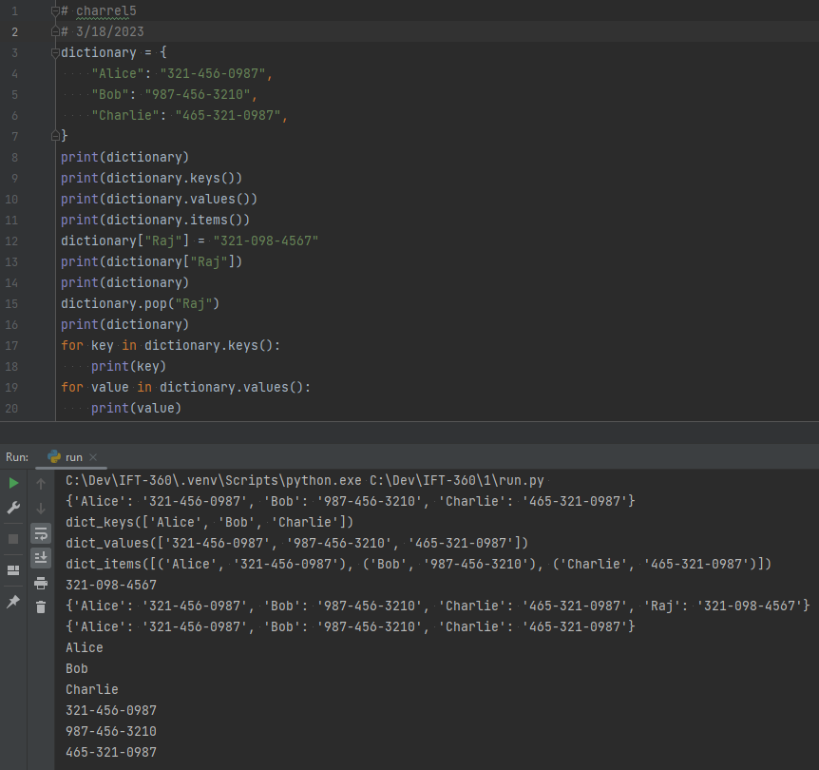

dictionary = {

"Alice": "321-456-0987",

"Bob": "987-456-3210",

"Charlie": "465-321-0987",

}

print(dictionary)

print(dictionary.keys())

print(dictionary.values())

print(dictionary.items())

dictionary["Raj"] = "321-098-4567"

print(dictionary["Raj"])

print(dictionary)

dictionary.pop("Raj")

print(dictionary)

for key in dictionary.keys():

print(key)

for value in dictionary.values():

print(value)

# 

# Concept 7

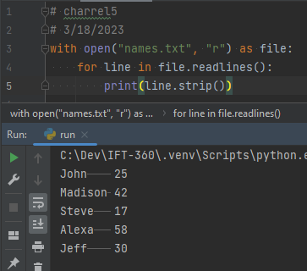

with open("names.txt", "r") as file:

for line in file.readlines():

print(line.strip())

# Concept 8

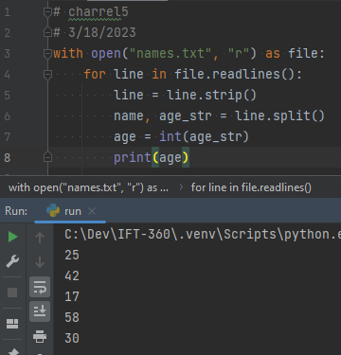

with open("names.txt", "r") as file:

for line in file.readlines():

line = line.strip()

name, age_str = line.split()

age = int(age_str)

print(age)

# Concept 9

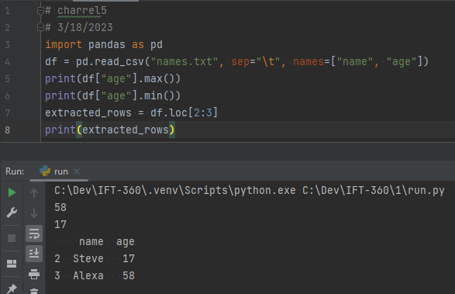

import pandas as pd

df = pd.read_csv("names.txt", sep="\t", names=["name", "age"])

print(df["age"].max())

print(df["age"].min())

extracted_rows = df.loc[2:3]

print(extracted_rows)